SEPTEMBER
written by Maurice Sendak

In September for a while 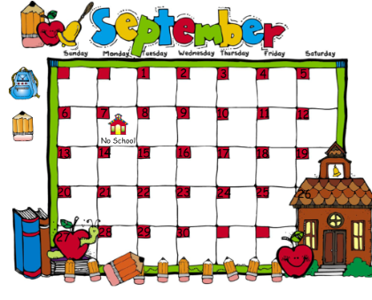

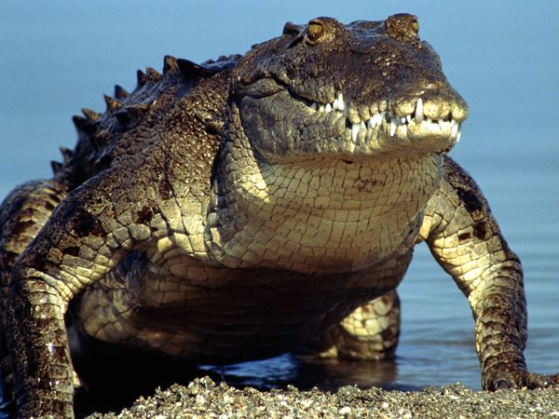 I will ride a crocodile

down the chicken soupy Nile 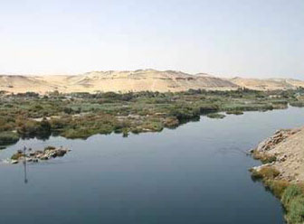

Paddle once, 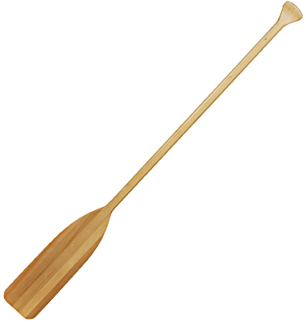, paddle twice ,

Paddle chicken soup with rice.

